Part 1
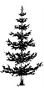
- (physics only)

Y
X
F
F
2F
2F

  - Draw the symbol for a convex lens at the point labelled X. (1)

  - What is the correct name for line Y? (1) Principal axis (1)

  - What is the correct name for the distance from point X to point F? (1) Focal length (1)

  - One ray has been partly drawn. Complete the path of this ray. Put an arrow on this ray (1)
  - Draw a second ray on the diagram to show how the image position can be found. (1)

  - Describe the image produced by this lens. (2)
Inverted, laterally inverted, reduced in size, real (1 mark / two correct responses)

- Below are two types of lens. Name each type of lens and complete the three light rays passing through each lens. (physics only) (4)

- (1)

Type of lens Convex (1) Type of lens Concave (1)

- A convex lens produces an image 35mm tall when a 5mm tall object is viewed. Calculate the magnification produced by this lens. (physics only) (2)

Magnification = image height (1) = 35 = 7
object height 5

Magnification = x7 (1)

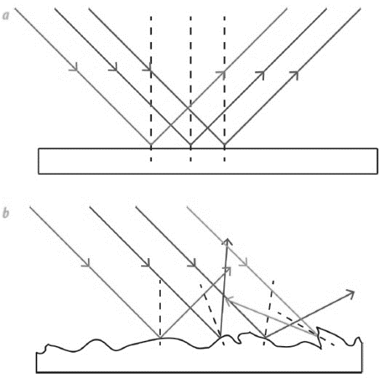
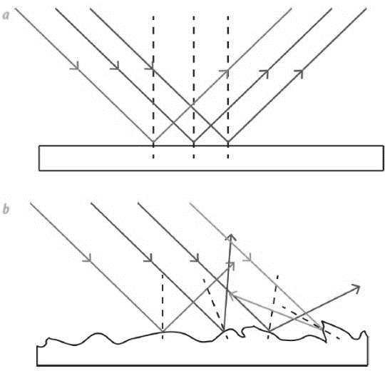
- The diagrams show light rays being reflected off two types of surface. (physics only)

B
A

  - What type of reflection is shown at A and at B? (2)

A Diffuse reflection (1) B Specular reflection (1)

  - Which surface is likely to be a smooth piece of white paper? (1) A (1)

- White light is shining on a green leaf and on a bottle of red juice.

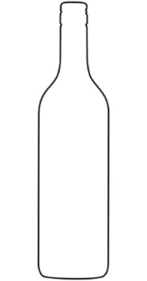
White light
Green light
White light
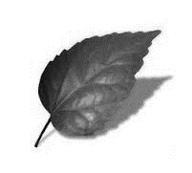
Red light

Describe what is happening to the spectrum colours of light in each diagram. (physics only) (4)

The leaf is reflecting green light (1)
All other colours of light are being absorbed by the leaf (1)
The red juice is transmitting red light (1)
All other colours of light are being absorbed by the juice (1)
- If a blue object in a dark room is illuminated with a red light, what colour will the object appear?
(physics only) (1)

It will appear black (1)

Part 2
- All electromagnetic waves have features in common. The table below lists features of waves. Tick the correct boxes that apply to all electromagnetic waves. (3)
Property | True | False
They are all transverse waves
They have different speeds
They have different frequencies
They all have the same wavelength
They can all be reflected, refracted and transmitted
They can all travel through a vacuum
1 mark / 2 correct responses
- The diagram below shows the electromagnetic spectrum. Three of the waves have not been named.
Radio | Microwaves | Infrared | Visible light | Ultra-violet | X rays | Gamma

Increasing frequency
- Fill in the three spaces above with the correct names. (3)
- Which of the waves above is used in TV remote controls? (1)
Infrared
- Which of the waves above is satellite TV? (1)
Microwaves

- When an infrared heater is switched on, a person a few metres away begins to warm up. Explain what has moved from the heater to the person and how this occurred. (2)
Energy has moved from the heater to the person (1)
This energy is carried by an electromagnetic infrared wave (1)

- The diagram shows a wave front being refracted as it enters a block of glass from the air (HT).

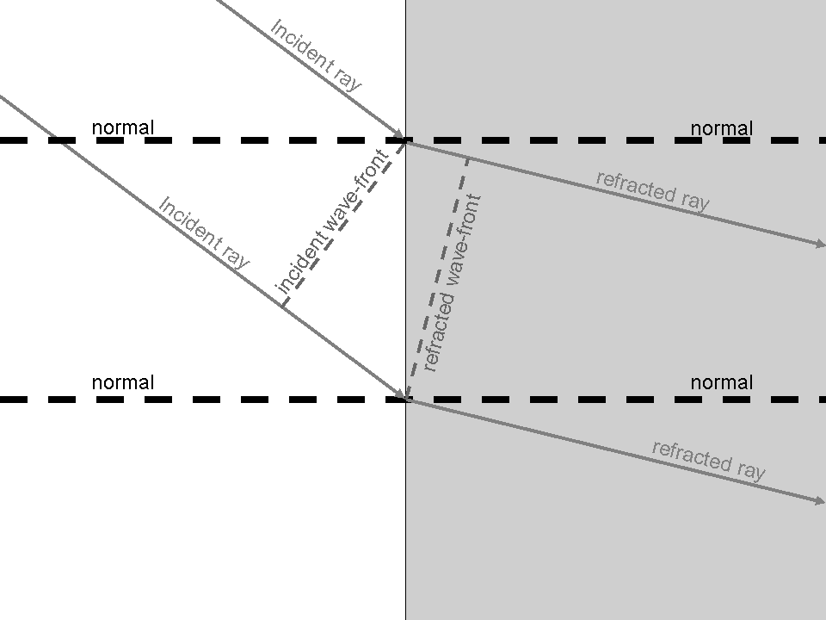

Explain in detail why the ray bends as it enters the glass. (3)

As the wave travels through the air, the top of the incident ray reaches the glass before the
bottom of the incident ray (1)

Glass is denser than air so the top of the wave slows down before the bottom of the wave
(1)

If one side of the wave slows before the other side, the wave will bend (1)
- Explain why a green object heats up more in sunlight than a white object (HT). (4)

A green object only reflects green light (1)
Other colours of light are absorbed by the green object causing its temperature to increase (1)
A white object reflects all the colours of light (1)
More energy is absorbed by the green object therefore its temperature will be higher than the white object (1)

- Television and radio broadcasts are sent through the air as radio signals.
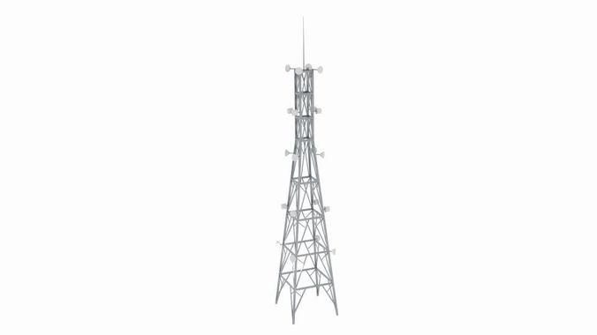
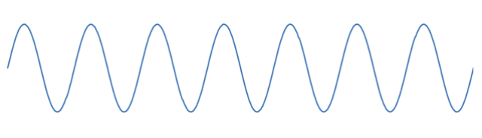
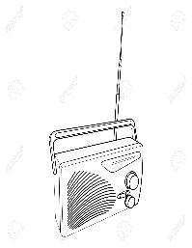

  - Why are radio waves suitable to send signals in this way? (1)

They transmit easily through the atmosphere (1)

  - How is the radio signal produced in the transmitting antenna? (2)

An alternating current is applied to the antenna (1)
These oscillations in the wire produce radio waves (1)

  - What is produced in the aerial of the radio when it receives radio waves? (2)

An alternating current (1)
Of the same frequency as the radio waves it receives (1)

- In which part of an atom are gamma waves produced? (1)

In the nucleus of the atom (1)

- The diagram shows the waves that make up the electromagnetic spectrum.

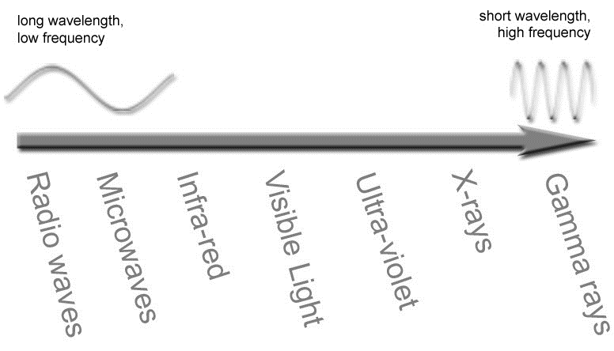

- Circle the waves that are ionising radiations. (3)

- What property of the spectrum of waves is shown to be increasing by the arrow? (1)

Frequency (energy) (1)
- What is the meaning of the term ‘radiation dose’? (1)

A measure of the amount of exposure to radiation (1)

- Explain why ionising radiations can be dangerous if the dose becomes high. (2)

A high dose can lead to mutations in cells of the body/ damage to DNA (1)
This can result in cancer caused by damaged genes (1)
- The waves shown below represent part of the electromagnetic spectrum.
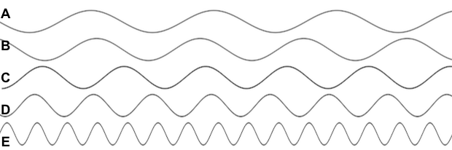

- Which wave is likely to be a radio wave? (1) Wave A (1)

- Which wave would be carrying the greatest amount of energy? (1) Wave E (1)

- Which wave could be used for medical imaging? (1) Wave E (1)

- If the waves represent the colours of visible light, what colour could wave C represent? (1)
Yellow / Green / Blue (1)

- Give the most suitable type of electromagnetic radiation for the applications stated: (5)

Application | Type of electromagnetic radiation
Satellite communications, cooking food | Microwave
Fluorescent lamps, disinfecting water, security marking | Ultra violet
Cooking, thermal imaging, short range communications | Infrared
Sterilising food and medical equipment, cancer treatment | Gamma
Vision, photography, illumination | Light

Property | True | False
A black body absorbs all radiation that falls on it
A black body always reflects radiation at a longer wavelength than that which it receives
A black body is an excellent emitter of radiation
A black body transmits all the radiation that falls on it
- The table describes some properties of a perfect black body. Put a tick in the correct box to show whether the statement is true or false. (4)

- A piece of iron is heated in a furnace until it is white hot.
How will the radiation emitted from the hot metal, differ from the radiation emitted when the metal was cold? (2)

Emitted waves will be at a higher frequency / shorter wavelength (1)
Emitted waves will be more intense / higher energy (1)
- The black cube below is in a warm room. Its temperature is constant.
What is the relationship between radiated and absorbed radiation for this object? (2)
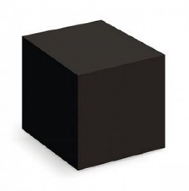

Black cube will be emitting radiation (1)

At the same rate that it is absorbing radiation (1)

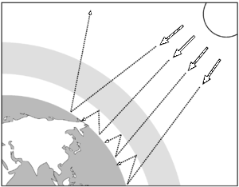
- The diagram shows how the Earth absorbs and emits radiation.

Use the diagram to help explain how changes between absorbed and emitted radiation could affect the temperature of the Earth. (4)

If more radiation is absorbed than emitted (1)
The average temperature of the Earth will increase (1)
Anything which prevents emitted radiation from escaping (1)
Will contribute to increasing the Earth’s temperature (1)

